**Ex. No.: 3 a**

**Date: 05.03.2024**

**EMPLOYEE AVERAGE PAY**

**Aim:** To find out the average pay of all employees whose salary is more than 6000 and no. of days worked is more than 4.

**Algorithm:**

1. Create a flat file emp.dat for employees with their name, salary per day and number of days worked and save it.

2. Create an awk script emp.awk

3. For each employee record do

a. If Salary is greater than 6000 and number of days worked is more than 4then print name and salary earned

b. Compute total pay of employee

4. Print the total number of employees satisfying the criteria and their average pay.

**Program Code:**

Emp.dat

John 1000 7

Jane 1100 5

Doe 7000 8

Smith 5000 6

Alice 6500 10

Bob 600 3

Emp.awk

BEGIN {

total_pay = 0;

count = 0;

}

{

name = $1;

salary_per_day = $2;

days_worked = $3;

salary_earned = salary_per_day * days_worked;

if(salary_earned > 6000 && days_worked > 4) {

print name, salary_earned;

total_pay += salary_earned;

count++;

}

}

END {

if(count > 0){

average_pay = total_pay / count;

print "Total no of emp satisfying the criteria: ", count;

print "Average pay of employees: ", average_pay;

}else{

print "No employees satisfy the criteria";

}

}

**Output:**

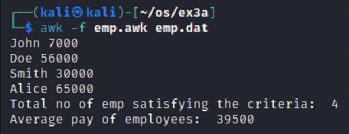

**Result:**

The above program executed successfully and output got verified.

**Ex. No.: 3 b**

**Date: 09.03.2024**

**Aim:**

RESULTS OF EXAMINATION

**Program Code:**

Student.dat

John 50 45 65 70

Jane 55 60 40 75

Doe 45 35 55 60

Smith 70 80 90 85

Alice 50 60 70 80

Bob 30 40 45 50

Ex3b.awk

{

name = $1;

subjects_failed = 0;

for(i = 2; i <= NF; i++){

if($i < 45){

subjects_failed++;

}

}

if(subjects_failed > 0) {

print name, "Fail";

}else{

print name, "Pass";

}

}

**OUTPUT**

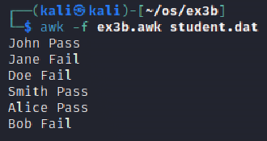

**Result:**

The above program executed successfully and output got verified.